Instructions for Project Linus Quilts for Donation by Lorraine Torrence (608) 467-9108
Basics:
* Finished quilts should be about 36” wide X 45” high. However, they can be as small as 36” x 36” and no larger than 54” x 72”.
* Draw a quilt design plan on graph paper to scale so you can see how many of each size piece to cut (+ seam allowance) and keep track of the layout.
* You may preshrink your fabric first – especially if you suspect some fabrics will shrink more than others. Some quilters like not to preshrink first so that their quilts will crinkle and become texturized after their first washing after being completed.
*When you design and plan your quilt, calculate all sizes as finished sizes, then cut pieces by adding ¼” to all sides of the finished size piece. Example: a finished 4 ½” square + ¼” added to each side would be cut 5” square.
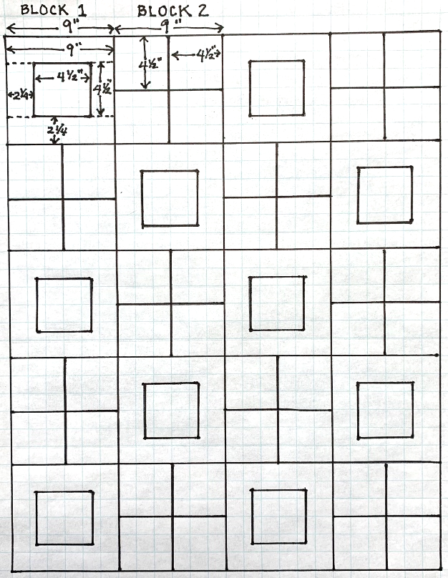
* Ideally, cut all pieces so they are on the straight-of-grain within the quilt. Bias edges at the edges of the squares or the quilt can be problematic. If you must cut pieces on the bias that are oriented straight within the quilt (for the sake of making a striped fabric go diagonally, for example,) it’s a good idea to stay stitch those bias edges so they don’t stretch and ripple.
Starting your quilt:
* After you plan your quilt’s finished size, you might want to
design the whole top within that size limitation, including a border if you want to incorporate one. Alternatively, you can
start making blocks the size that you would like and then see
if it needs a border at the end. (See maximum sizes in the first item under “Basics” above.) This plan-as-you-go method is fine, but it is harder to make sure you will have enough of each fabric you need when you make your choices spontaneously as you work. If you are working with a fabric kit, if is safer to plan your quilt within those limits.

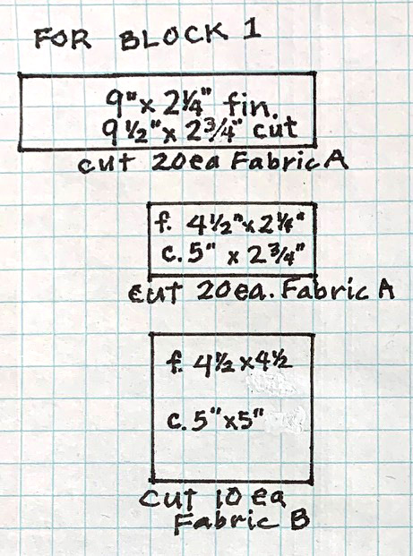
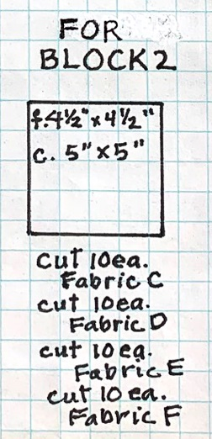

* After you have a plan and know where each where each fabric will go, count the number of
pieces– and their sizes with seam allowances
added – you will need to cut of each size from
each fabric you have. Do you have enough fabric to do that? If you have ALMOST enough of a few fabrics, but there are odd sized pieces left over, consider enlarging a too-small piece with the leftover scraps by piecing them.
* Cutting is most quickly done using a rotary cutter, cutting ruler
and cutting mat. If you do not have these tools, make templates
from cereal-box weight cardboard by cutting out graph paper full
sized pieces, gluing them onto the cardboard and cutting them
out with a ¼” seam allowance added on all sides. Place the templates on the back sides of their respective fabrics and draw around them with a sharp pencil. Eileen suggests that you may also make templates out of foam core board which can serve as an edge
around which to cut shapes with a rotary cutter.

Sewing your Quilt:
* Lay out each block’s cut pieces the way you want them to look.
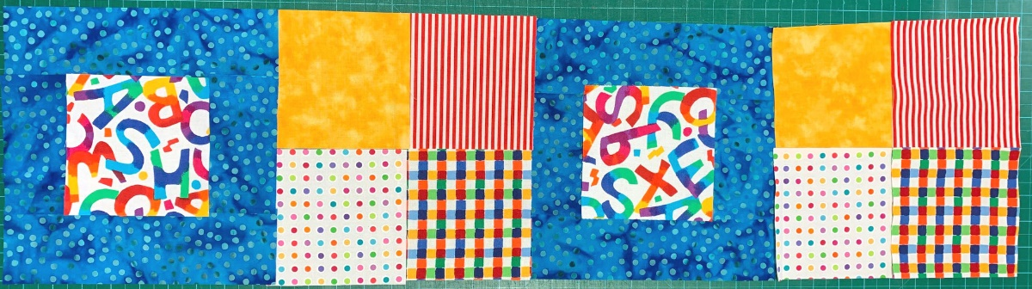

*Sew the blocks together using a ¼” seam allowance (I use a ¼” foot for all quilt piecing for accuracy.)
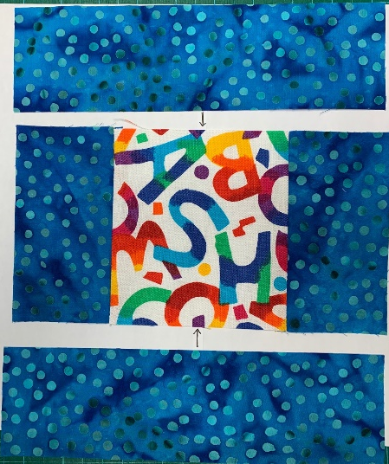
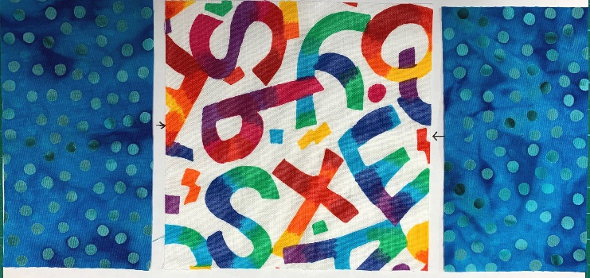

For Block 1, sew the short pieces to the center square first and press seam allowances open of to the center. Next, sew the long pieces to the 3-part center piece. Press seams open or to the center.
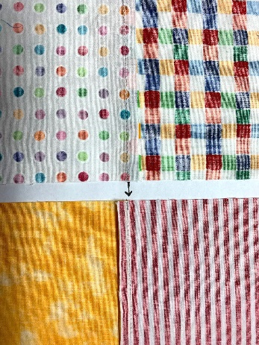
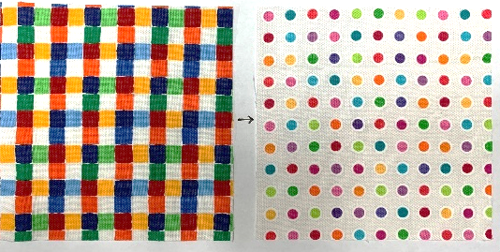
For Block 2, determine the arrangement of the four 5” squares and sew the top two of the 5” squares together and press the seam one direction. Next, sew the other two squares together and press the seam in the opposite direction. Then sew the two sections of Block 2 together, butting the two opposing seams together to match the seams and press the seam open.
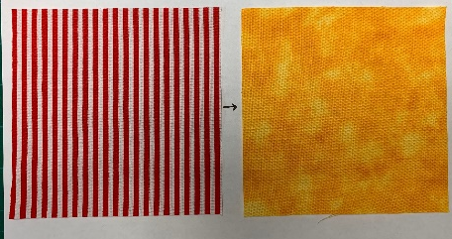

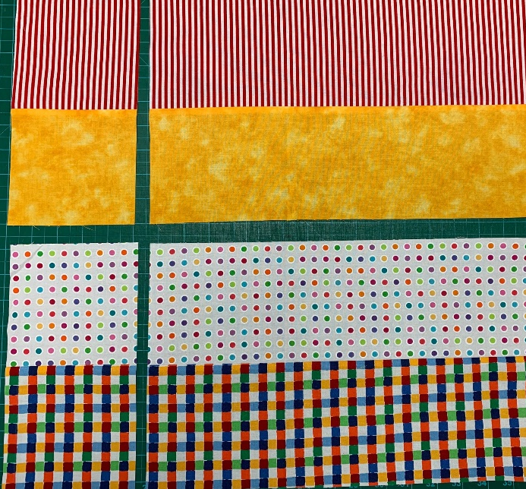
* Sew 4 alternation blocks together for the first row of the quilt. Press the seam allowances of the blocks in each row in opposite directions to create opposing seams for easier matching of crosswise seams. It will make your job easier if you are accurate about the width of your seam allowance in each seam and sew straight seams. Press seams after sewing.
* You can speed up the piecing if you make strip sets of recurring combinations. For example, if you need to sew the same two pieces of 5” squares of fabric together for use in several or many squares, you may cut 5” strips of those two fabrics, sew them together, press the seam to one side and then cut across the strip every 5” at a 90° angle to create the same combo as many times as you need to.

* Lay out your finished blocks in the arrangement you have planned and like, and then sew the rows together, matching seams carefully and pressing them open now for less bulk.
* (Optional) Once you have finished sewing the rows together, you may add a border of whatever width you think looks good. Sew the side borders on first and trim them even with the top and bottom, pressing the seams toward the outside. Then sew the top and bottom borders on, trimming the ends square and pressing the seams out. If you like you can even make the borders of more than one strip. If you do this, you may sew all the border strips together first, but make them longer than each side of the quilt by a bit longer than the width of the border at each end. Stop sewing each border on ¼” before you get to the edge of the quilt center. This will enable you to miter the borders at the corners sewing a 45° angle from where you stopped sewing on the borders to the border edges.
Finishing Your Quilt
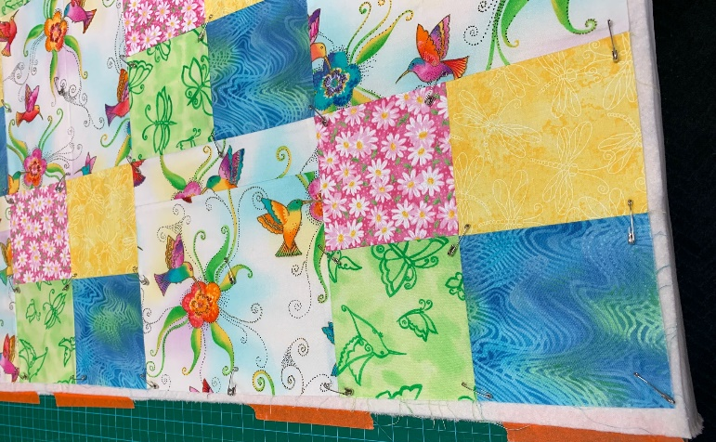
* Quilts are made with three layers: the top, a batting, and a backing. Cut the batting and the backing a bit bigger (1/2” – 1 ½”) than the front (or top) of the quilt. If you are using a kit, it is possible that the fabric included for the quilt back may not be quite big enough. If this is the case, piece more fabric from kit leftovers or from your own stash to make it big enough.
* (Option 1) Please note that a different quilt is pictured for this part of the process. If you choose to bind your quilt at the edges, first sandwich the three quilt layers so the batting and backing stick out beyond the quilt top on all sides. The back should be placed on the floor or a big table, wrong side up, and taped down with masking tape so it is smooth and flat. Then smooth the batting on top of the back and then smooth the quilt top, right side up, on the top, making sure there is backing and batting extending beyond the edge of the quilt. Safety pin-baste the layers together. Skip Option 2 and go to the next instruction.
* (Option 2) If you prefer to sew the layers together, right sides together like a pillow case, layer the front and back together, right sides together, with the batting on one side of the sandwich, smoothing all layers and pin basting to keep layers from shifting. Stitch all the layers together at edge of the quilt top using a 1/4-3/8” seam allowance, leaving a 12” opening at one side. Sewing around the edges of the quilt is most successfully done using a walking foot. Trim the batting very close to the seam line and the back ¼” from the seam line. Remove the pin basting and turn the quilt through the opening. Smooth the layers and pin baste the layers together again. Turn in ¼” and hand stitch the opening closed.
* Machine quilt either option above at this point. Use about a 2.7mm-3mm stitch length and a walking foot (for straight-line quilting) or a darning foot (for free motion quilting) to avoid shifting of the layers. Quilt however you like, but it is best to keep the density of the quilting about the same all over.
* If you chose layer, baste and quilt your quilt to prepare for binding it, now that it is quilted, it is time to stitch around the unfinished edge of the quilt about ¼” from the raw edge of the quilt top.
Binding your Quilt
Once that is done, trim all three edges even with the edge of the quilt top. Now you are ready for binding.
* Binding can be straight of grain or cut on the bias. Straight of grain binding saves fabric; bias binding conforms best to the edge of the quilt.
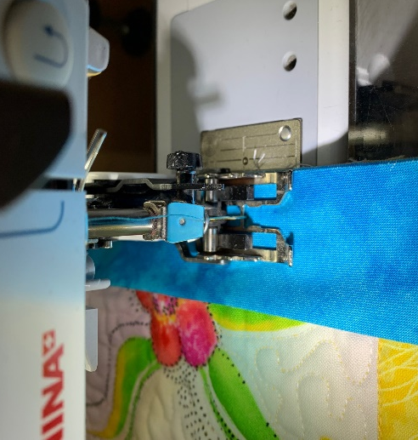
* If you want to use single thickness binding, cut strips straight across the width of the fabric, 4 times the width of the binding with which you want to finish your quilt plus an extra ¼” to account for the “turn-of-cloth” or the depth of the wrap. For example, if you want the width of the binding to be ½”, finished width, cut your binding strips to 2 ¼” wide. If you want to use double width binding (to be folded in half – right side out - and stitched on the edge of the front of the quilt with the two raw edges of the binding even with the raw edge of the quilt,) cut the binding 6 times the width of the binding you want plus an extra 3/8”. Sew binding pieces together using 45° cuts whether they are straight of grain or bias strips. Press seams open. Fold ¼” to the inside of the beginning end of the binding to create a clean, finished beginning edge.

* Using a walking foot to prevent the quilt layer from shifting, sew the binding to the quilt edge (beginning at least 3-4” down from the beginning end of the binding to allow for the overlapping of the ending of the binding as it comes around to meet the beginning) right sides together using a seam allowance that is the slightly scant measurement of the desired quilt binding.

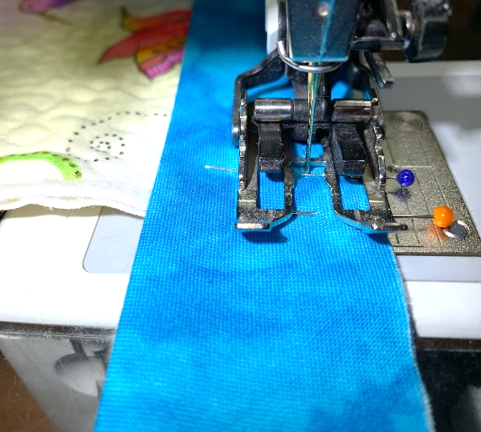
* As you come to each corner, stop sewing and back-stitch before you get to the next edge of the quilt by the width of the binding measurement, which should be the same as your seam allowance width. For example, if you are sewing a ½” (or scant ½”) seam allowance, stop sewing and backstitch ½” (or a scant ½”) before you get to the next edge of the quilt. Take the quilt out from under the presser foot and snip the threads close to the quilt surface.
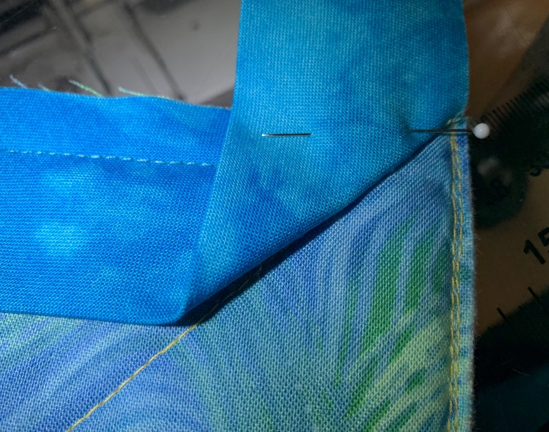

* Now, fold the binding away from the next edge of the quilt, whether it is doubled or not, so it is stretched out the opposite direction from the next edge you will be sewing (a.) When you do this, the next edge of the quilt and the continuing edge of the binding raw edge(s) will be forming a continuous straight line, and the fold in the binding will be a 45° angle.
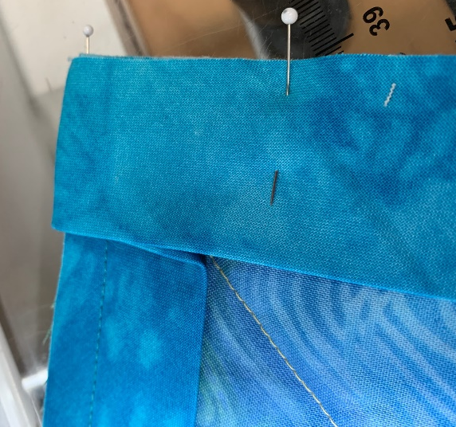

*Now, fold the binding back along the next edge of the quilt, pinning the raw edges together. There will be a straight fold of the binding at the edge of the quilt to which you sewed the previous edge of the binding.
* Sew down the second edge of the binding-to-quilt-edge using the same seam allowance you used for the first side. Repeat the process at each subsequent new corner and new side until you come around to close to where you started and stop sewing. Cut the final end of the binding at a mirrored angle of the first 45° angled edge of the binding and cut off so there is at least a ¼” overlap – or slip inside of the folded edge of the doubled binding, ending with a mirrored, angle cut. Sew the final joining place to the edge of the quilt.
* Wrap binding around the quilt edge and pin to cover the initial stitching with the already folded edge - OR fold a final seam allowance of single bias into the inside to cover the initial stitching. Fold the binding into a miter on the back corners of the quilt and pin in place. Hand stitch the binding down on the back, OR machine stitch-in-the-ditch on the quilt front right in the seam used to sew on the binding, making sure you catch the folded binding edge on the quilt back. ALL FINISHED!

